***Payroll***

***System***

***WHAT IS PAYROLL?***

Payroll is very simple, flexible and user-friendly Management software. That takes care of all your requirements relating to accounting and management of employees’ Payroll. Payroll stores complete records of the employees, generates Pay-slips and Attendance Register, Computes all allowances and deductions and generates all statutory reports.

Payroll Application has been designed for the purpose of maintaining details of various allowances and deductions that needs to be given to the employees of the organization.

***Works of the team members:***

***Project Analysis and Project Planning***

* *Dharmendar Kumar Meena*

***Software Requirement Analysis***

* *Anjali Mittal*

***Data Modeling Use Work Products***

* *Harshit Gupta*

***Software Developments And Debugging, Software Testing, DFD and ER Diagram***

* *Kaushal Surana*

***PROJECT PLANNING AND ANALYSIS***

***SCOPE:***

Today Organizations are maintaining most of their day-to-day transactions data in the register’s work is done manually (i.e. maintained in registers) so different employees are appointed for the maintenance of registers containing all the information related to the organization.

It is very time consuming and is also not error free in some situations. In existing manual system databases calculations are difficult to perform so report generation as very much difficult.

***PLANING:***

To enhance the working of such organization we have planned to build a software which can be used by the organisation to pay the employee with no error and low human power will be required for maintaining the records of the employees using the software than the register system.

***MAIN MOTIVE:***

The proposed will also prevent unauthorized access to the system. At the very beginning, the password is to be entered by the user and if it is correct only then the permission to use the software is given to user.

***USER:***

A person who knows how to operate a computer system and has a little interaction with the C programming language.

***ADMINISTRATOR:***

He might be the head of the organization or a member whom he trust as the password will be shared only with single person for the security of the data.

***SOFTWARE REQUIREMENT ANALYSIS***

***SOFTWARE DEVELOPMENT PROCESS MODEL USED:***

***COMPONENT BASED MODEL***

This model was used by us to complete the software rapidly and easily. We found some components from our previous project and some using internet.

Phases defined under the development of the project are

1. Requirement Analysis:

This was done for understanding of the project and was done by the use of internet as we are some students of science and didn’t know about the payroll system.

1. Designing:

In this phase we divided the software into small modules such that no module was affecting the work of another module.

1. Construction:

In this we used some components from our libraries to speed up the project and constructed the new part that was required to complete the software. eg. The password section was copied from the previous software.

1. Testing:

First the module level and then the system level testing was done.

1. Deployment:

The software was delivered and feedback were asked and changes were made according to the requirement.

***SOFTWARE REQUIREMENTS:***

Operating system: Windows 98, XP

Specific application: A compiler of C++ is required. Turbo C++ is referred as the software is made using the same compiler.

***HARDWARE REQUIREMENTS:***

A computer system that has the capacity to install all the above application.

* 1 GB RAM
* Storage according to the size of your organisation. i.e. number of employees.

***DATA MODELING USED WORK PRODUCTS***

***Use Case Diagram:***

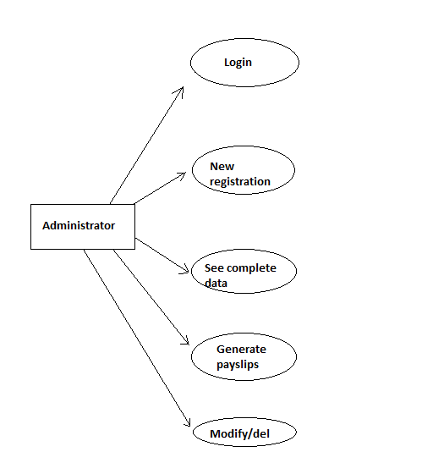

***Activity Diagram:***

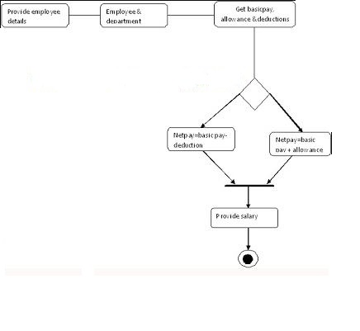

***ER Diagram:***

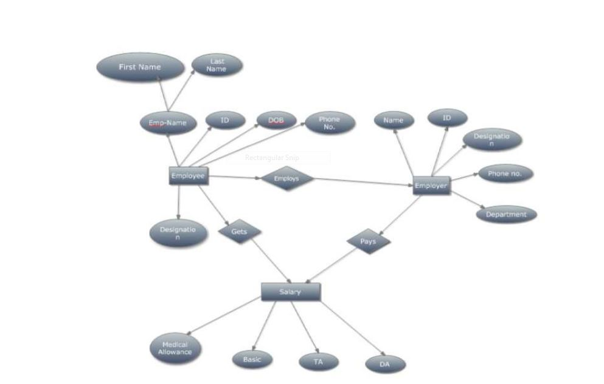

***Data Flow Diagrams:***

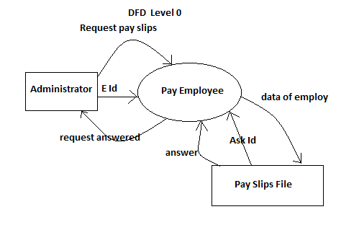

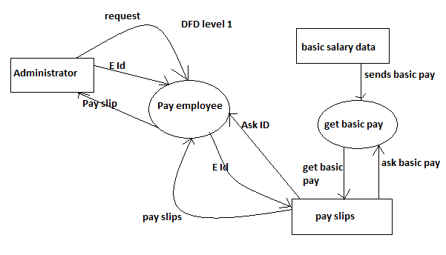

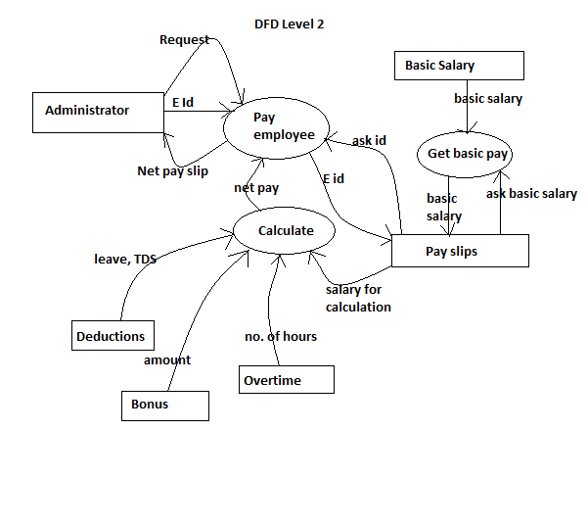

***Data Dictionary:***

In this project we have used only one object that stores the basic information about the employee. The data about the employee is as follows:

Sr. No. Variable Name Data Type Uses

1 fname String Stores the first name of employee

2 lname String Stores the last name of employee

3 eid Integer Stores the employee id of employee

4 doj Structure Stores the date of joining of employee

5 desig Integer Stores the designation of employee

6 basepay Long int Stores the basic salary of employee

***Coding***

#include<iostream.h>

#include<conio.h>

#include<string.h>

#include<stdio.h>

#include<process.h>

#include<iomanip.h>

#include<fstream.h>

int check(int *);

void show_part_emp();

void register_emp();

void pay_slip();

void display();

void modify();

void delete_rec();

int chepass(char []);

void chanpass();

class employee

{

char fname[20],lname[20];

long int basepay;

int desig;

struct date

{

int day,month,year;

}doj;

public:

int eid;

void input();

void showdata();

void calculate();

}s,r;

fstream pass;

void main()

{

int ch;

char pword[20],p[10]="employee";

clrscr();

pass.open("passwd",ios::in|ios::out);

if(pass.get()==EOF)

pass<<p;

pass.close();

while(1)

{

clrscr();

cout<<"Enter your choice\n\n1.Register new employee\n2.Generate\

Payslips\n3.See organisation data\n4.See patricular data\n5.Modify\n\

6.Delete record\n7.Change Password\n0.Exit\n";

cin>>ch;

if(ch>0&&ch<8)

{

cout<<"Enter password\n";

cin>>pword;

if(chepass(pword))

{}

else

{

cout<<"wrong password\n";

getch();

break;

}

}

switch(ch)

{

case 1:register_emp();

break;

case 2:pay_slip();

break;

case 3:display();

break;

case 4:show_part_emp();

break;

case 5:modify();

break;

case 6:delete_rec();

break;

case 7:chanpass();

break;

case 0:exit(0);

break;

default:cout<<"WRONG CHOICE\n";

getch();

break;

}

}

}

void chanpass()

{

char psword[20],pword[20];

cout<<"enter new password\n";

cin>>psword;

cout<<"enter again\n";

cin>>pword;

pass.open("passwd",ios::out|ios::trunc);

if(strcmp(pword,psword)==0)

{

pass.seekp(0,ios::beg);

pass<<psword;

cout<<"password changed\n";

}

else

cout<<"don't match\n";

pass.close();

getch();

}

void employee::input()

{

int ye,d,m;

cout<<"enter the following details of the employee\n";

cout<<"First Name : ";

cin>>fname;

cout<<"Last Name : ";

cin>>lname;

cout<<"Date of joining\n";

cout<<"Year : ";

cin>>ye;

while((ye<1950)||(ye>2017))

{

cout<<"year should range between 1950to now.\

Enter correct year again\n";

cin>>ye;

}

doj.year=ye;

cout<<"Month : ";

cin>>m;

while(m>12||m<1)

{

cout<<"wrongly entered.enter again 1-12\n";

cin>>m;

}

doj.month=m;

cout<<"Day : ";

cin>>d;

while((d>31)||((m==4||m==6||m==9||m==11)&&d>30)

||(m==2&&ye%4!=0&&d>28)||(m==2&&d>29))

{

cout<<"wrong day entered . Enter again \n";

cin>>d;

}

d=d+200;

doj.day=d;

cout<<"Basic Salary: ";

cin>>basepay;

cout<<"Enter your designation\n";

cout<<"1. Senior manager\n2. Junior Manager\n3. Supervisor\n4.Line \

Employee\n";

cin>>desig;

while(desig>4||desig<1)

{

cout<<"Wrong Entry.... Enter again\n";

cin>>desig;

}

}

void employee::showdata()

{

cout<<eid<<"\t"<<fname<<" "<<lname<<"\t"<<basepay\

<<"\t"<<doj.day-200<<"-"<<doj.month\

<<"-"<<doj.year<<"\t";

switch(desig)

{

case 1:cout<<"S M";

break;

case 2:cout<<"J M";

break;

case 3:cout<<"S V";

break;

default :cout<<"L E";

}

cout<<"\n";

}

void employee::calculate()

{

int l,o,b,flag=0;

long int lp,op,bp,total;

cout<<"enter the no. of leaves\n";

cin>>l;

lp=(basepay/30)*l;

cout<<"No. of overtime hours\n";

cin>>o;

op=basepay/250*o;

cout<<"Percentage Bonus given : ";

cin>>b;

while(b>20||b<0)

{

cout<<"Bonus should be between 0 to 20%... enter again";

cin>>b;

}

bp=basepay*b/100;

total=basepay+bp+op-lp;

if(total>99999)

{

flag=1;

total=total-(total/20);

}

clrscr();

cout<<"Name : ";

cout<<fname<<" "<<lname<<endl;

cout<<"Employee Id.: ";

cout<<eid<<endl;

cout<<"Basic salary : ";

cout<<basepay;

cout<<"\nLeave Deduction : ";

cout<<lp;

cout<<"\nOvertime Pay : ";

cout<<op;

cout<<"\nBonus : ";

cout<<bp;

cout<<"\nTDS : ";

if(flag==1)

cout<<"5%";

else

cout<<"No Deduction \n";

cout<<"Net Pay : ";

cout<<total;

cout<<"\n\n\n\npress any key ...";

getch();

}

int chepass(char psword[20])

{

char p[20];

pass.open("passwd",ios::in);

pass.seekg(0,ios::beg);

pass>>p;

pass.close();

if(strcmp(p,psword)==0)

return 1;

else

return 0;

}

void delete_rec()

{

ifstream fil;

int id;

cout<<"Enter the employee Id. whose data is to be removed\n";

cin>>id;

ofstream o;

o.open("new.dat",ios::out|ios::binary);

fil.open("emp.dat",ios::in|ios::binary);

if(!fil)

cout<<"File not found\n";

else

{

fil.seekg(0,ios::beg);

while(fil.read((char *) &s,sizeof(s)))

{

if(id!=s.eid)

o.write((char *) &s,sizeof(s));

}

o.close();

fil.close();

remove("emp.dat");

rename("new.dat","emp.dat");

}

}

void display()

{

ifstream fil;

fil.open("emp.dat",ios::in|ios::binary);

int i=0,n;

long int size;

fil.seekg(0,ios::beg);

size=fil.tellg();

fil.seekg(0,ios::end);

size=fil.tellg()-size;

n=size/sizeof(s);

cout<<"number of employees are: "<<n<<endl;

fil.seekg(0,ios::beg);

while(fil.read((char *) &s,sizeof(s)))

{

if(i<21)

{

cout<<"E.Id\tName\tBasic pay\tDate of join\tDesignation\n";

s.showdata();

i++;

}

else

{

cout<<"Press any key for next page\n";

getch();

i=0;

}

}

getch();

}

void show_part_emp()

{

ifstream fil;

int id,flag=0;

cout<<"Enter the employee Id. whose data is to be shown\n";

cin>>id;

fil.open("emp.dat",ios::in|ios::binary);

fil.seekg(0,ios::beg);

while(fil.read((char *) &s,sizeof(s)))

{

if(id==s.eid)

{

cout<<"E.Id\tName\tBasic pay\tDate of join\tDesignation\n";

s.showdata();

flag=1;

break;

}

}

if(flag==0)

cout<<"data not found\n";

getch();

}

void register_emp()

{

int id,i;

ofstream fil;

fil.open("emp.dat",ios::app|ios::binary);

while(1)

{

cout<<"Enter the employee id\n";

cin>>id;

i=check(&id);

if(i)

break;

else

cout<<"this id already exist\n";

}

r.eid=id;

r.input();

fil.write((char *) &r,sizeof(r));

cout<<"enter any key...\n";

getch();

fil.close();

}

int check(int *id)

{

ifstream fil;

int i,flag=0;

while(*id/10000!=0||*id/1000<0)

{

cout<<"Id should be of 4 digit... Enter again\n";

cin>>i;

*id=i;

}

fil.open("emp.dat",ios::in|ios::binary);

while(fil.read((char *) &s,sizeof(s)))

{

if(*id==s.eid)

{

flag=1;

break;

}

}

fil.close();

if(flag==0)

return 1;

else

return 0;

}

void modify()

{

fstream fil;

int id,i,a;

fil.open("emp.dat",ios::in|ios::out|ios::binary);

cout<<"Enter the id of the employee whose data is to be modified\n";

cin>>id;

i=check(&id);

if(i==1)

cout<<"no data found\n";

else

{

a=id;

while(i==0)

{

cout<<"enter new id\n";

cin>>id;

i=check(&id);

if(i==0)

cout<<"This id is already allocated\n";

}

fil.seekg(0,ios::beg);

while(fil.read((char *)&s,sizeof(s)))

{

if(s.eid==a)

{

s.eid=id;

s.input();

break;

}

fil.seekg(0,ios::cur);

fil.seekp(fil.tellg()-sizeof(s));

fil.write((char *) &s,sizeof(s));

fil.close();

}

}

}

void pay_slip()

{

ifstream fil;

int id,flag=0;

cout<<"Enter the employee Id. whose pay slip is required\n";

cin>>id;

fil.open("emp.dat",ios::in|ios::binary);

fil.seekg(0,ios::beg);

while(fil.read((char *) &s,sizeof(s)))

{

if(id==s.eid)

{

s.calculate();

flag=1;

break;

}

}

if(flag==0)

cout<<"data not found\n";

fil.close();

getch();

}

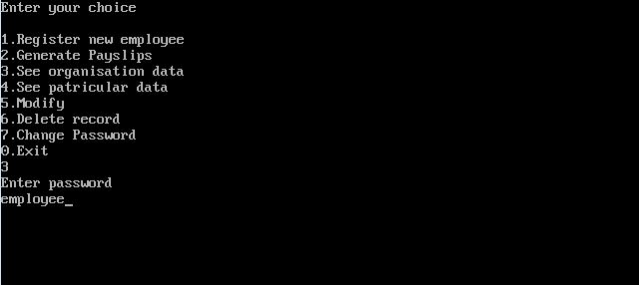

Opening page

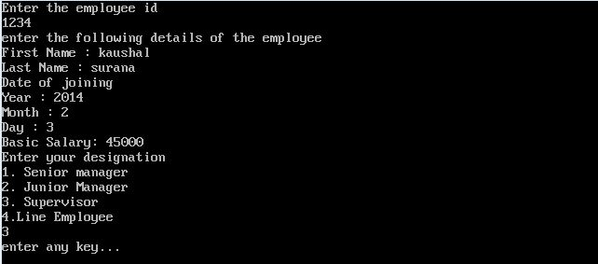

Registration page



Show data

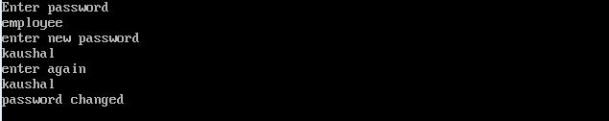

Changing Password